**Test Mail Server**



**Introduction**

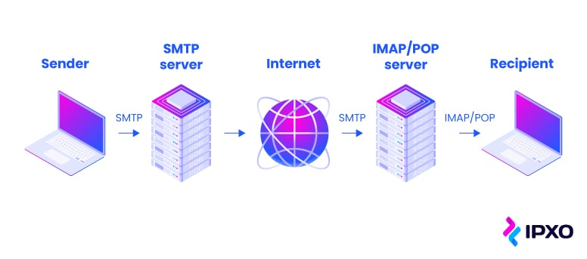

Testing a mail server is essential to ensure its configuration is correct and that it is capable of sending and receiving emails securely. This process helps in identifying configuration issues, verifying DNS records, and ensuring the mail server is not vulnerable to common exploits.

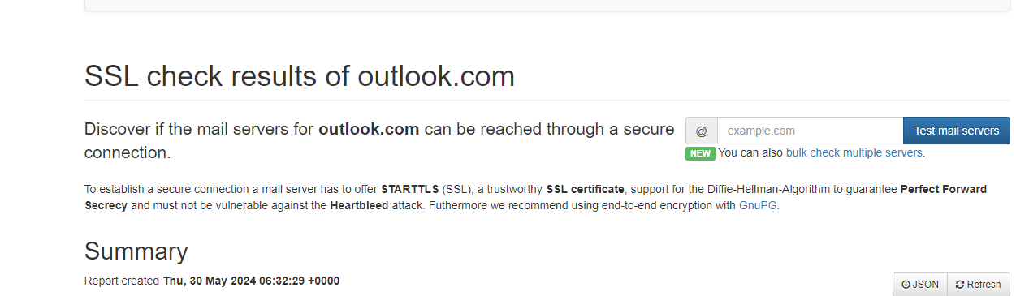

**Scenario**

Imagine you are a system administrator responsible for setting up and maintaining your organization's mail server. Before putting the server into production, you need to verify its configuration to ensure that it can handle email communications securely and efficiently. Using the mail server testing tool you will check and analyze the mail server's setup.

**Process to Perform**

**Step 1:** Click on this link to access Certificate decoder <https://ssl-tools.net/mailservers> or open any web browser on your PC and type **SSLtools** in the address bar.

**Step 2:** Click on the second link and click on Test Mail Server

**Step 3:** Enter **outlook.com** in the search bar.

**Step 4:** Capture the Flag

**Questions**

Flag 1: What is the IP address of this date 2021-08-05?

Answer: 40.92.42.12

Flag Captured

Flag 2: Is the(141.98.116.137) IP address encrypted?

Answer: No

Flag captured

Hint

